[1]

Social Media Analysis

Tahseen Begum., Alwala Raghavendra Goud, Abhiram Vidiyala, Rokkam Vivek Vardhan Reddy,

Dr.Arpita Gupta

*Department of Computer Science and Engineering, KLH University.*

*R.V.S Nagar, Moinabad-Chilkur Road, near AP Police Academy, Aziznagar, Telangana, India.*

[tahseen7412@gmail.com](mailto:tahseen7412@gmail.com) , [*shivagoud163@gmail.com*](mailto:shivagoud163@gmail.com), [abhiramvidiyala11@gmail.com](mailto:abhiramvidiyala11@gmail.com),[*vivekvardhanreddy7777@gmail.com*](mailto:vivekvardhanreddy7777@gmail.com)*.*

[arpitagupta2993@gmail.com](mailto:arpitagupta2993@gmail.com)

*Abstract*—Social media is extremely vital to think about analyzing fashionable society as an entire, their values, norms, and behaviors, as being a district of our daily life. This study is familiarized with analyzing social media so as to permit users to make their own preferences to follow (analyze) a selected social media supply. the online application has been developed to permit a user to follow specific Facebook, Instagram, Snapchat, and YouTube accounts and categorize Facebook, Instagram, Snapchat, and YouTube posts on those accounts supported by the user-outlined taxonomies.

*Index Terms*— Facebook, Instagram, Snapchat, YouTube, Machine learning algorithms

# INTRODUCTION

I

n the modern world, social networks have become an integral part of everyone’s life. we often share sensitive information with other people and tell everyone about our interests, hobbies, so we leave a digital footprint. by analyzing this information, you can get a lot of useful data that can later be used, for example, by employers or teachers. based on this data, people can be organized into high-performance teams where positive atmosphere can help facilitate their work and provide for the effective interaction. it is a great opportunity for employers to identify their future employees during job interviews. In modern realities of the remote format due to the coronavirus, this can simplify the algorithm for selecting eligible employees and reduce the possibility of making a wrong decision. It can also make it possible for schoolteachers and headmasters to assign students to classes in such a way that they could feel comfortable and find like-minded people from young age. is “Text”).s

Social media platforms are currently utilized by a huge number of individuals in order to express their political perspectives, individual passionate states, or financial inclinations over social media platforms. The information that is delivered by these platforms can be very useful to understand the situation of the individual or a group individual. This enormous measure of information has expanded the estimation of the huge information idea, which is one of the famous and quickly creating marvels right now. This field has begun showing new answers for the difficulties in numerous zones by aiding with new strategies of development. Social media and its investigation tools are applied over social media as the result of innovation in this century that can provide new aspects in accomplishing improvements in various fields. The data on social media requires information storage and methods that are required for managing and filtering required information out of that size of data. This field can be a huge point in the future on which investigation can be performed that can lead us to improvements in various fields Highlight a section that you want to designate with a certain style, then select the appropriate name on the style menu. The style will adjust your fonts and line spacing.

# Proposed work

The study tried to explores the use of social media for and help people and end user and specially influencers who make living from the social media . it would also help the new generation to understand how this market works because we need to be up to date in the industry of media, fashion and modern days lifestyle; this project helps the new millennials what is the best place to invest themselves through the type of content they could offer so that they get a profitable income and fame.

# Author List

Tahseen Begum, Rokkam Vivek Vardhan Reddy, Alwala Raghavendra Goud, Abhiram Vidiyala.

# PROBLEM STATEMENT

The social media era,the social media influences the entire current generation through the use of social networking for digital marketing and evaluating the social networking sites as a medium of advertisement .the influencers are on all kinda platforms, but they are majorly available on Snapchat, Instagram, Facebook, You Tube, tic tok etc; our project is based on data visualization in which we have chosen to visualize the various DATASETs of different social medias, in which we have to visualize the user activities ON MANY famous social media platforms using data visualisation techniques.Now a days, people spending more time on social media and influencing the various activities like travel , blogging , start-ups and many business. So this project is based on analyzing the various influencers activity on social media

our project is based on data visualization in which we have chosen to visualize the dataset of many user activities on many famous social media platforms using data visualisation techniques.

# LITERATURE SURVEY

1,author: Aleksandra Tešin*, Tatjana Pivac, Snežana Besermenji, Sanja Obradović; title: EXPLORING THE INFLUENCE OF INSTAGRAM ON TRAVEL DESTINATION CHOICE; published on Received: August 17, 2021Correction: September 17, 2021Accepted: November 8, 2021; techniques: sociodemographic characteristics, correlation analysis,independent samples t-test,ANOVA test; pros: The assumption that Instagram has the most influence on travel plans and destination selection in the case of active users of this social network has also been confirmed.Instagram has been widely used by the general population that spends a lot of time online, it can be concluded that Instagram is a good source of information and promotion, which should be valued. It is one of the main inspiration sources when choosing a travel destination. Cons: Given the variety of Instagram sources that provide such content, in the future, the focus may be on a particular profile (e.g., travel companies, NTO, DMO, travel bloggers) or a type of photo or video related to tourism. It would be useful to include qualitative research to better understand the type of content and social media presentations that influences the decision to visit a particular destination the most. Another suggestion is to examine the potential negative side of Instagram, whether it leads to overcrowded destinations or deters tourists from visiting them

2, author: 1Muthiara Chairani , 2Subiyantoro; title: Males and females’ complimenting behaviour on the celebrities’ Instagram comments; published on Received: Jan 22, 2021, Revised: Sept 29, 2021, Accepted: Nov 11, 2021; techniques: Sex-Based Distribution of Direct Compliment Patterns by Manes & Wolfson (1981), Sex-Based Distributions of the Compliment Forms

Pros: Instagram commentby sex-based perspective revealed that females gave more compliments than males. Females were more likely to address compliments at the same sex than across sex. Both males and females used direct compliment forms than  
indirect compliment forms.; cons: an indirect compliment is needed to classify certain categories or subcategories in indirect compliments, both in face-toface and virtual interactions. Moreover, more research is also still required to distinguish the complimenting behavior between virtual interaction and face to face interaction within a certain social group/community.

3, author: Marianne Kaappola; title: CSR Communication on Instagram before and during COVID-19 ; published on 11-01-2022 ; techniques: CSR communication, destination marketing,content analysis; pros: Destination marketing as such is certainly a success for all accounts, as the layouts of the accounts with their images are really beautiful and attractive. In all of them, Finland's four different seasons came to the fore in a nice way.All in all, it was surprising that responsibility appeared so little in the Instagram accounts of these towns, even when there was the highest volume of CSR communication. It made me ask myself whether communicating about responsibility is at all necessary in the social media of regional tourism organizations; Cons: the COVID-19 is still not over, but communication  
about it in the various media has been left out of other crisis communication due to the situation in Ukraine. CSR communication was an interesting topic and somewhat new to me. So, I learned quite a lot about both what is meant by responsibility and how responsibility should be communicated. I found the content analysis method to be laborious but functional. It got a lot of different things out of the posts, and it also made the data easier to illustrate. The corona pandemic changed almost everything in such a significant way that it was clear that it would be reflected in the results as well. What was prominent however, was that even during the pandemic, its impact  
on communication diminished, and I think the same phenomenon has been seen in everything else.

4, author: Kateřina Kvěchová1; title: An Analysis of Products Communicated on Instagram by the Most followed Czech Influencers; published on September 2020; techniques: marketing agency,product-related posts by influencers ; pros: The aim of this contribution was to determine and analyse the types of products the five most followed Instagram influencers in the Czech Republic promoted during the period September 2019 - September 2020. The influencers were identified on the basis of the highest number of followers; cons : there successfully able to show the complete analysis.

# DATA SETS

We have explored various sources and collected datasets to understand different types of social media data and their behavior to train our model accordingly.

we have used various types of social media datasets which are trending these days.

We collected the data from Instagram, Snapchat, Facebook, You tube to explore the user activities and their status .

->Helping the user to find out the activities through insights of collected data.

->Data pre-processing is a data mining technique which is used to transform the raw data in a useful and efficient data.

We have 4 data sets of different types of platforms like Snapchat, Instagram, YouTube, Facebook

Snapchat has entities such as usernames, rating, reviews, etc.

Instagram has entities has Username, Channel Name, Country , URL, Main topic, Main video category, Likes, Likes Avg., Posts, Followers, boost Index, Comments Avg, Views Avg, Avg. 1 Day Avg, 3 Day Avg, 7 Day Avg, 14 Day Avg, 30 Day Engagement Rate, Engagement Rate (60 Days).

For Facebook we have entities such as userid, age, dob_ day ,dob_year, dob_month, gender tenure friend_count friendships initiated ,likes, likes received ,mobile likes, mobile_likes_received, www_likes, www_likes_received

For YouTube we have entities such as rank Youtuber, subscribers, video views, video count, category, started.

# METHODOLOGY

With the datasets collected from the Kaggle we will now analysis and visualize the data and try to understand the patterns and insights and relationships between the data .

To achieve the goals and the objectives that have been set and finalized, an Explorative and Descriptive research is needed to be done. For Starters we need to find the customers that got aware of the product via digital marketing . Afterwards shall go and check that how much has the company spent on digital marketing and product promotion. We shall also collect data that how well was the company doing before implementing modern day strategies such as Digital Marketing and how well has it has impacted the product selling, and we shall compare this data to the data that shall tell us that how well did the business did after the implementation of the modern day technology and modes of business such as online selling, digital marketing, Popup Ads. Afterwards in order to understand the role of Social Media Marketing, we also need to understand the number of clients that the company got through social media platforms such as Facebook, Instagram or any other platform. This can be checked and verified by checking the stats and records of the company

We use different libraries for analysis of the data, we will clean the data and use plots to view or see data.

Panda is basically used in data analysis where we load the data from the drive or the external source like (www).

Numpy is used for array or multi dimensional array’s .

matplotlib. pyplot is a collection of functions in the popular visualization package Matplotlib. Its functions manipulate elements of a figure, such as creating a figure, creating a plotting area, plotting lines, adding plot labels, etc.

then we clean the data, remove the unwanted columns rows try to find the empty cells and duplicate cells by adding null values to it so that data wont alter at the same time we can visualize the data without errors, then we uses plots to analyses the data.

We do this for all the four data sets we gathered we continue the same procedure, first we load the data then we try to read and clean the data and analyze the data accordingly.

Then starts the visualization part, we have used Tableau desktop for the visualization of the data.

We first load the cleaned data into the tableau desktop and try to visualize in a way that we can track the patterns, insights, and relationships between the data.

# RESULTS

Fig 1. Snapchat dashboard.

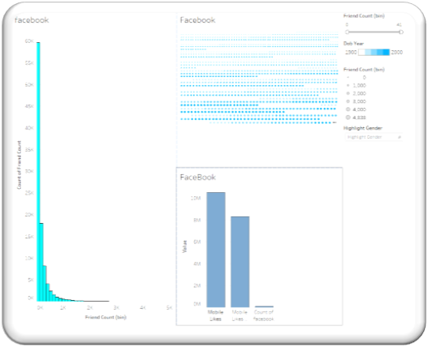

Fig 2. Facebook dashboard.

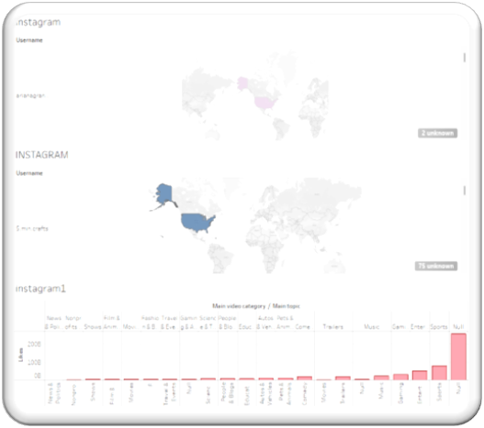

Fig 3. Instagram dashboard.

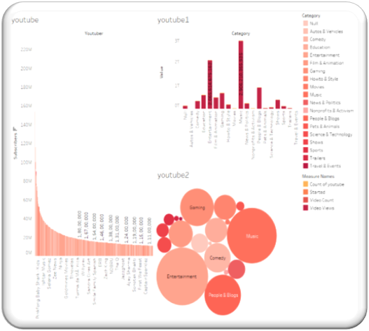

Fig 4. You Tube dashboard.

Fig 5. Story (all dashboards on single platform)

# Conclusion

Social media has taken its position into the $64000 world and has interfered with the lives of the many. As users go browsing to their social media profiles, they're being removed faraway from the $64000 world and placed into the virtual dimension. By this project we can analysis the data and know about the social media at a single platform, we can work on the insights and pattern we want to progress on the field that is more profitable. We can also choose the platform through which they want to show their content and talents too. This project will become a common ground for beginners who wants to chose a platform to start through and for the experts to improve their content.

# REFERENCES

1. Milkyas Hailu, Jianhua Wu, "The Use of Academic Social Networking Sites in Scholarly Communication: Scoping Review", Data and Information Management, vol.5, no.2, pp.277, 2021.
2. Weiwei Yan, Qian Liu, Ruoyu Chen, Shengwei Yi, "Social networks formed by follower–followee relationships on academic social networking sites: an examination of corporation users", Scientometrics, vol.124, no.3, pp.2083, 2020.
3. M. Armstrong, A handbook of human resource management practice, Kogan Page Publishers, 2006.
4. Mihuandayani, E. Utami and E. T. Luthfi, "Profiling analysis based on social media for prospective employees recruitment using SVM and chi-square", Journal of Physics: Conference Series, vol. 1140, pp. 012043, dec 2018.
5. M.-S. Viñan-Ludeña, "A systematic literature review on social media analytics and smart tourism", Smart Tourism as a Driver for Culture and Sustainability, pp. 357-374, 2019.

1. .